Google Earth Hometown: Before and After

Before: April 1992

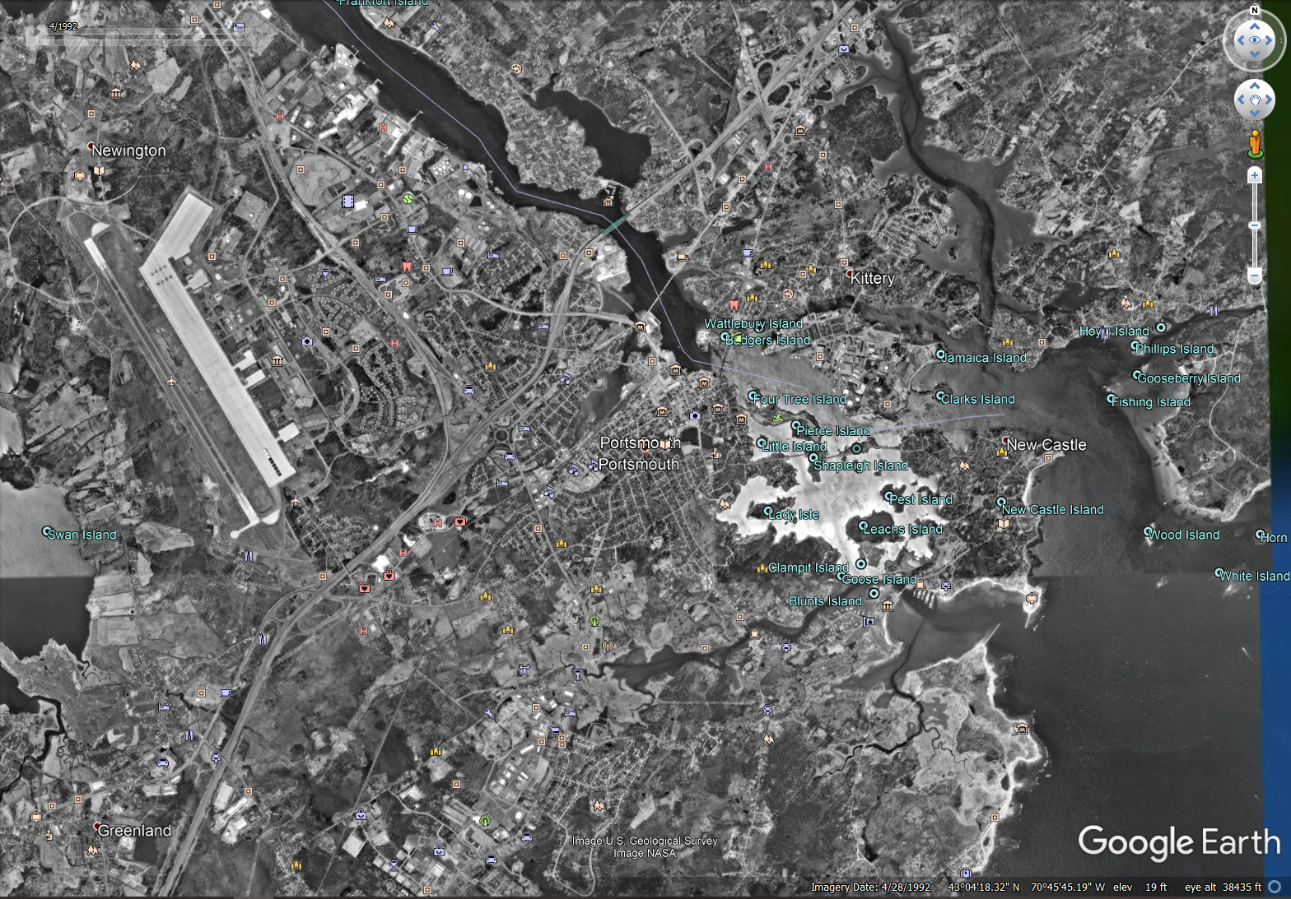

After: May 2018

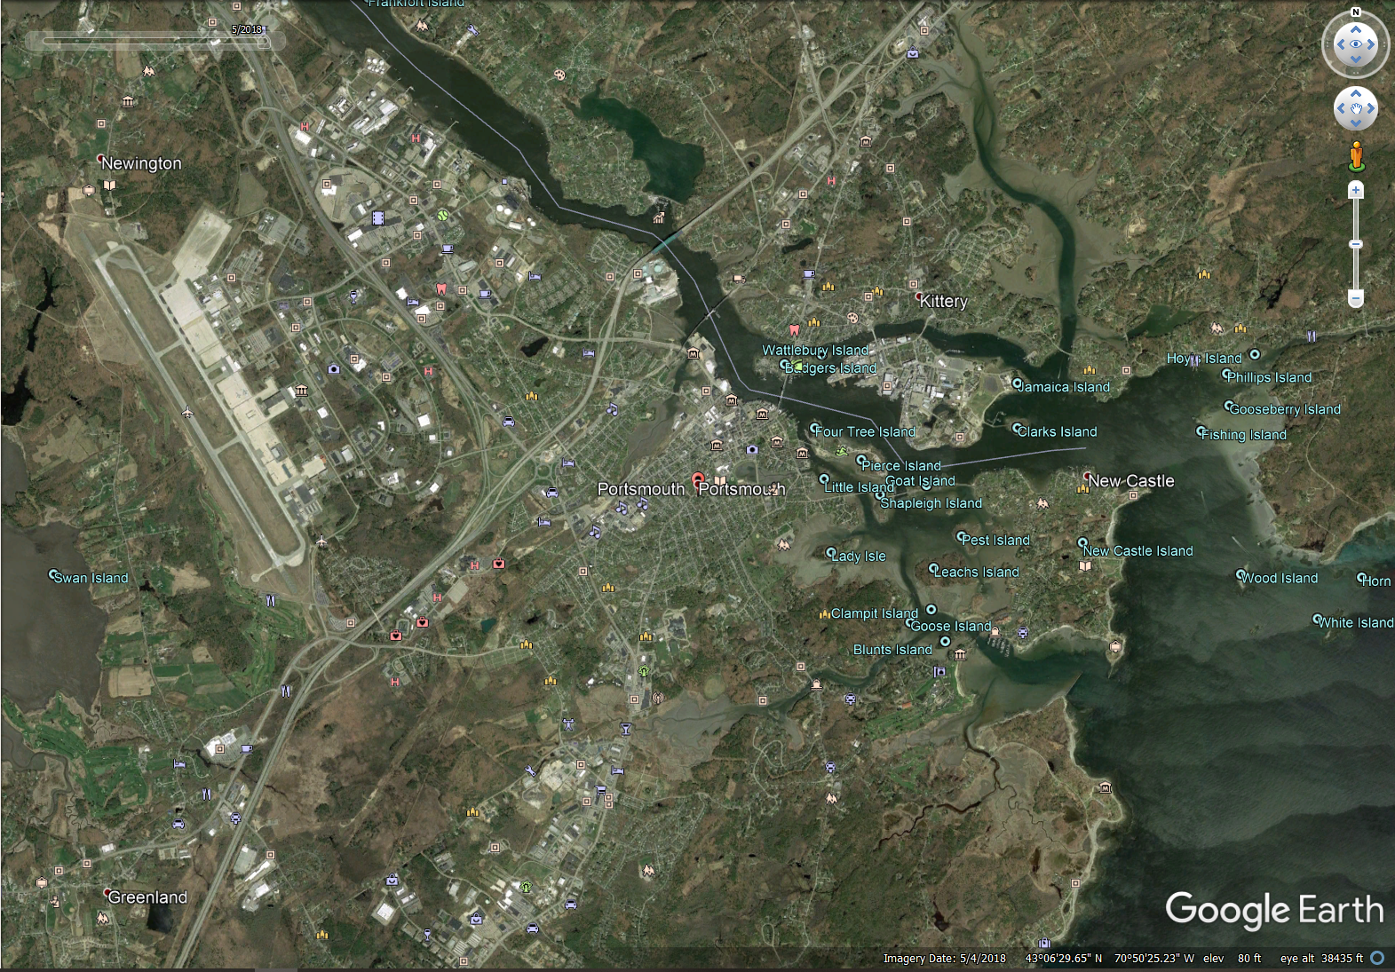

* Portsmouth High School Renovation: Late 2003
* Portsmouth Junior High School Renovation: Late 2010
* Portsmouth Naval Shipyard Development: Continuous
* Pease Air Force Base Development: Continuous
* State Street Saloon Fire: 2017
* Sarah Mildred Long Bridge Renovation: 2015
* Portsmouth Waterfront Development: 2013
* Memorial Bridge Renovation: 2011

Portsmouth has undergone “rapid” development over the past decade. This coastal New Hampshire town has risen in popularity, price, population and all sorts of manners. As a life-long resident of Portsmouth I’ve seen the effect firsthand, accounting for inflation the price of my family’s property has doubled since 1997 not accounting for renovations and upgrades. The more physical changes can be viewed through Google Earth Pro. Portsmouth High School and Junior High School have both undergone renovations in 2003 and 2010 respectively. Traffic as a result of this increased population has been mitigated through traffic and road changes, such as the 2015 Sarah Mildred Long and 2011 Memorial Bridge renovations. Lastly, the major changes visible through comparing the 1992 and 2018 satellite imagery is the continuous development on both the Pease Air Force Base and the Portsmouth Naval Shipyard.